Chapter 4 Science Study Guide Name:______________
- Where are the newest oceanic crusts located?

- Name the ancient continent that contained all of the landmasses.

- According to Wegener, when did the continents originally break apart?

- The same types of rocks, rock structures, and fossils have been found to exist on many different continents. What theory does this support?

- What is glossopteris?

- Why does sea floor spreading occur?

- What type of currents inside Earth might be a cause of sea floor spreading?

- As new oceanic crusts form, the older oceanic crust moves_____________

- __________is the theory that continents have slowly moved over time to where they are now.

- True or false: Convection provides matter and energy for plate motion

- The speed of plate movement could be compared to the growth of a _________________.

- Two types of lithosphere are _______________ and __________________.

- Matter and energy for plate motion are provided by ______________.

- What causes hot, plastic-like rock in the asthenosphere to rise toward Earth’s surface?

- Which layer of the Earth can be described as thick, and made of granite and gneiss?

- What are the two things that happen when the edges of plates run into, move apart, or scrape past each other?

- Earth’s _______________ field has reversed itself many times.
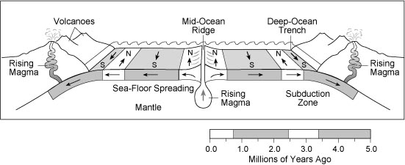
- Understand this
diagram (also found on
page 176).

