In ancient times, the _______________ River flowed parallel to the Indus River until an earthquake most likely caused it to dry up.
Historians can tell that Harappan leaders were _______________ by studying the remains of their cities, which required much planning and organization to build.
Harappans were skilled _______________, as evidenced by the ruins of planned cities with square corners, heavy brick walls, and structures such as homes, shops, and large public buildings. Also, they made bronze statues and clay toys, showing that they could have more than just the basic necessities. This was because they gained much wealth from _______________ and _________________.
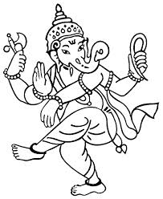
Harappans had a similar pattern of civilization development as the _________________ of ancient Mesopotamia, as both developed advanced civilizations from simple villages.
Most people in early India belonged to the caste (level) called ________________.

The most important sacred text of Hinduism is called the _________________________________.
During King Asoka’s reign, many Hindus became ________________ because the Hindu religion’s rites and ceremonies were conducted in a language that only the priests could understand.
During the reign of ____________________________, the arts and sciences/mathematics flourished and became very advanced in India.
When Arab traders traveled to Europe for trade, they brought with them a system of numbers that most countries in the world use today (1,2,3,4,5,6,7,8,9) called the _____________________________.
Martin Luther King, Jr. was inspired by the Indian leader named _________________________, who practiced ______________, which means non-violence, to accomplish goals in society.
MAP SKILLS: Study the map on page 237. Understand what the symbols in the key/legend mean.
- Recognize which river served as an approximate western border for one empire.
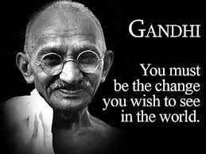
- Understand which city would be where the king would rule from.
ESSAY TOPICS: You’ll choose one topic. Start your response by restating the question.

- Explain how Ahimsa links Jainism, Hinduism, and Buddhism:
  - what is ahimsa
  - how do Jains practice ahimsa and Hindus practice ahimsa
  - explain the teachings of the Buddha
- Explain how India’s caste system and Hinduism are linked:
  - tell what a caste is, and how a person is placed into one of those levels
  - explain which three groups the Aryan society was originally organized into
  - connect the Hindu belief of how devout Hindus must faithfully carry out their assigned duties in life in order to achieve a connection with God

