Know what moniker was given to Abraham, and why.

____________ led the Israelites out of ________, where they lived as slaves for hundreds of years.

The Israelites nicknamed Canaan the “_________________ Land” because _______________________.

Once out of Egypt, the Israelites divided into ___ tribes, each named after a descendant of Jacob.

King David led the Israelites in battle to defeat the ________________________.

King Solomon’s achievements:
- formed new __________ alliances, and improved on the ties already formed with Phoenicia
- built the __________ and many other building projects
- made Israel more powerful
- was known for being a very ________ king

After King Solomon died, ____________ became the ruler. This new ruler’s policies caused problems which led to Israel splitting into the kingdoms of __________________ & __________________.

What happened to the Israelites’ name during the time of Babylonian Captivity?

The Romans conquered Israel and changed the name of _________________ to _________________.

Know a similarity and a difference (success?) between the Maccabees and Zealots:

The second Temple of Jerusalem was destroyed in the year __________.
MAP SKILLS: Study the map on page 337. Understand what the symbols in the key/legend mean.
- Become familiar with the bodies of water and cities. Know which kingdom had more cities.
- Know where the city of Jerusalem is located, in relation to both kingdoms.

FAMILY TREE: Jacob was the father of the 12 tribes of Israel; he had 4 wives who had 12 children total.

ESSAY TOPICS: You’ll choose one topic. Start your response by restating the question.
- The Jews viewed themselves as a chosen people, which shaped their long history.
  - covenant made with ______
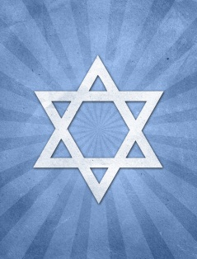
  - their view of the land of Canaan
  - what gave Jews hope throughout hard times
- The reigns of King Saul, King David, and King Solomon were different.
  - how each became king
  - achievements of each
  - roles in building Israel into a better nation

