[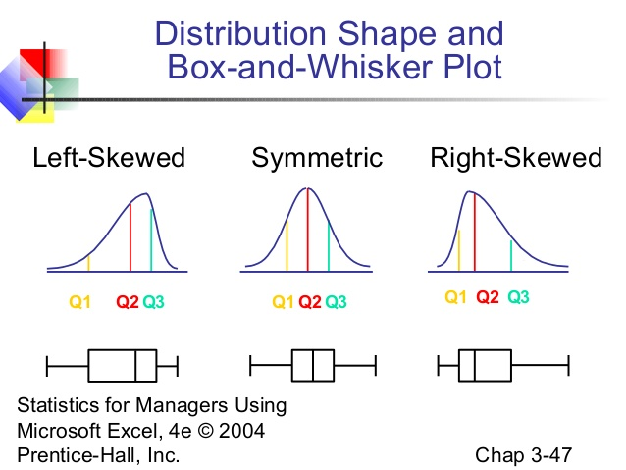](http://www.slideshare.net/UniSrikandi/chap03-numerical-descriptive-measures)

[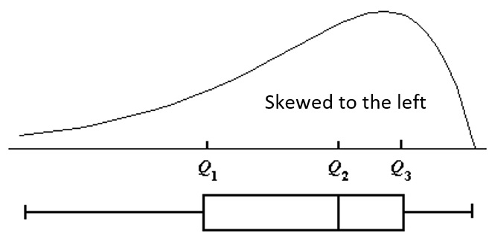](https://onlinecourses.science.psu.edu/stat200/book/export/html/1)

[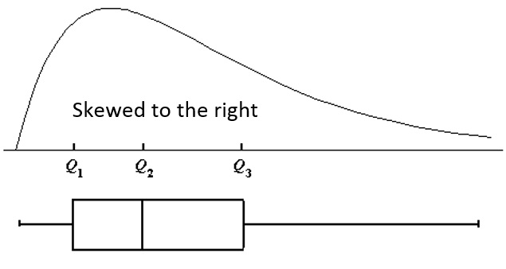](https://onlinecourses.science.psu.edu/stat200/book/export/html/1)